Assisted Practice: 29 Name: Prajwal Diwakar

Random Variables and Counters.

Random Variable:

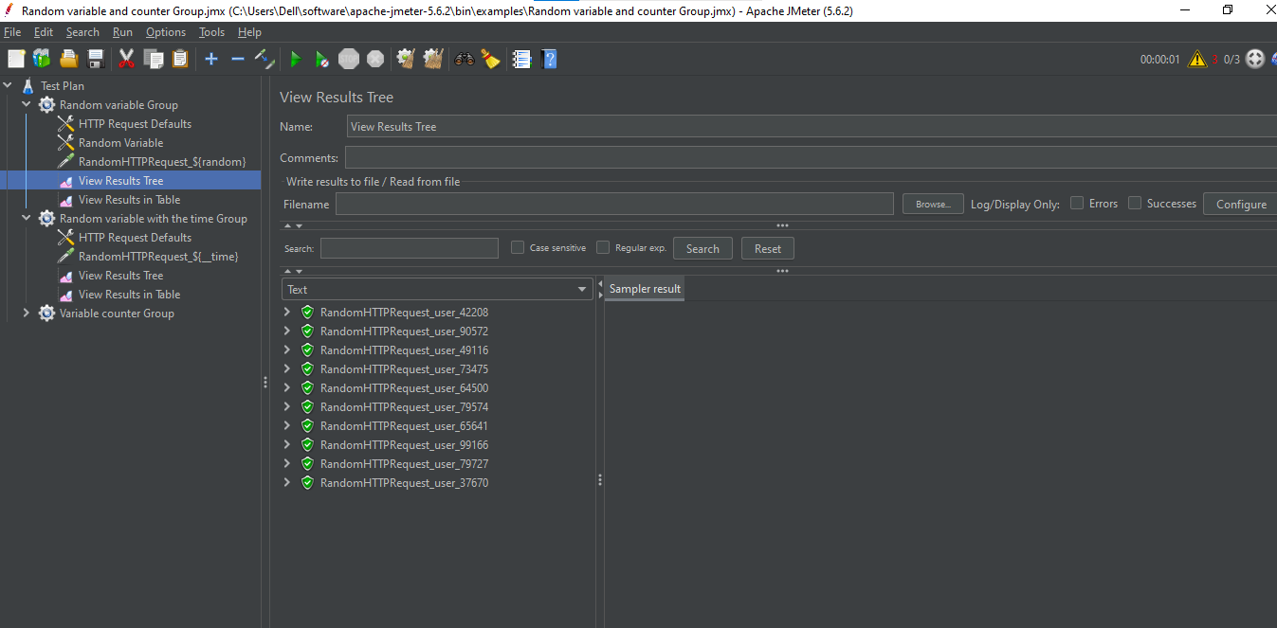

Counters:

